Holley Part # 558-313
Holley EFI Adapter for FAST Dual-Sync Distributors

Wiring

  - 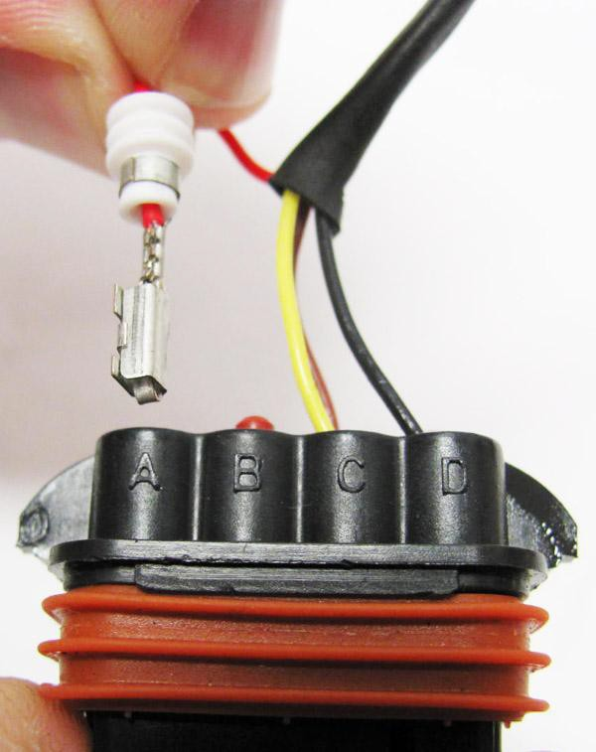Connect the 10 pin female connector of the 558-313 adapter harness to the male 10 pin “Ignition” connector in the Holley EFI main harness.

  - Once the distributor is installed, the FAST™ distributor connector can be connected to the adapter. The FAST™ has a loose red wire that needs to be connected to a switched 12V ignition source. There is a supply for this in the 558-313 adapter (Pin A on the 8 pin female connector). To connect the switched 12V wire to the 558-313 adapter, first crimp the included pin and seal onto the loose red wire in the FAST™ harness.

  - Next, remove the plastic lock on the back of the male 8-pin FAST™ connector. Remove the cavity plug, if there is one, and insert in pin A. See Figure 1. Re-attach lock. If you do not do this, connect this red wire to a switched 12V ignition source.

Adapter Wiring: Red Wire: Switched +12V Yellow Wire: Cam Signal Brown Wire: Crank Signal
Black Wire: Signal Ground Figure 1

Distributor Installation

Install the distributor per the instructions included with the distributor. Use the “50 degree reference angle” instructions.

Holley EFI Software Setup

  - In the “System Parameters” ICF, under the “Ignition Parameters” tab, select an “Ignition Type” of “Custom” (Fig 2).

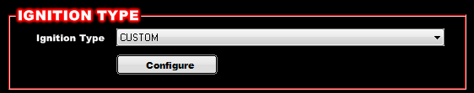

Figure 2

  - Select the “Configure” tab and enter the information per Figure 3. This is assuming you are triggering an MSD/CD Ignition box.

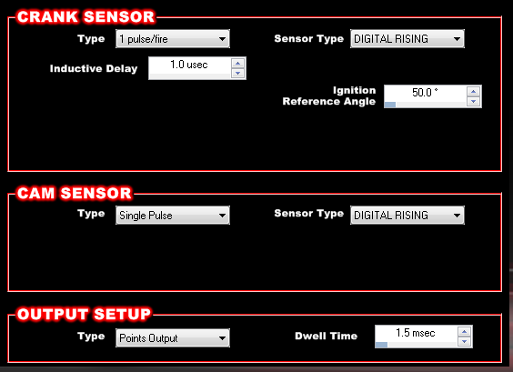
Figure 3

  - Firing Order Change: Holley EFI expects the cam signal to occur in a certain position. For this to occur in the correct location, you’ll need to change the firing order. To do this, move the cylinder that is first in the firing order, to the last position. The following example shows what you’d need for a standard Chevy V8, changing the firing order from 1-8-4-3-6-5-7-2 to 8-4-3-6-5-7-2-1. Figure 4 shows how this should look when completed.

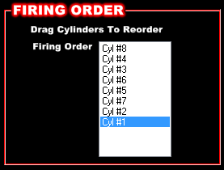
Figure 4

  - Once the Holley EFI Global Folder is updated, you can send it to the ECU. Cycle the ignition key before starting the engine.

Starting Engine and Timing Verification:

It is best to verify that the timing is close to the proper position before firing the engine. Disconnect the fuel injector harness connector, so fuel won’t be injected when the engine cranks. Attach a timing light to the engine and connect a laptop to the ECU. Crank the engine over and check the timing by looking at the “Ignition Timing” in the data monitor. It should be dictated by the “Cranking Timing” set in the software (typically 15 degrees). If the timing is within a few degrees, the engine is safe to start.

Reconnect the fuel injector harness and start the engine. Once running, you can use the “Set Static Timing” feature to lock the timing to a fixed value (located in the same area as the TPS Autoset function). Look at the Ignition Timing value in the data monitor. This should match the value read with the timing light. If it does not match, you have two options:

- The first is to simply turn the distributor housing until the timing light shows the value the laptop does (which you should do if the timing is off more than 5 degrees).
- The second option is to change the “Ignition Reference Angle”. If the timing light shows a retarded value, decrease the Ignition Reference Angle. If the actual timing is too far advanced, increase the Ignition Reference Angle. Make sure you cycle the ignition key after sending these changes to the ECU before you recheck.

EFI Expert support: 209-247-6497

