FAST Man EFI
21575 Apple Hill Dr.
Sonora, CA. 95370

fastmanefi.com
209-247-6497

Setting up 700+ lb/hr Billet Atomizer Injectors using Holley ECU Drivers and 2nd/3rd set with 554-142/143 Module and V5 Software

How to Setup Billet Atomizer 700+ lb/hr injectors in V5 with internal ECU drivers (when using for the first set).

- Select the custom injection type then click configure injector sets. Select “Custom” for the Injection Type. Then select “Configure Injection Sets”.

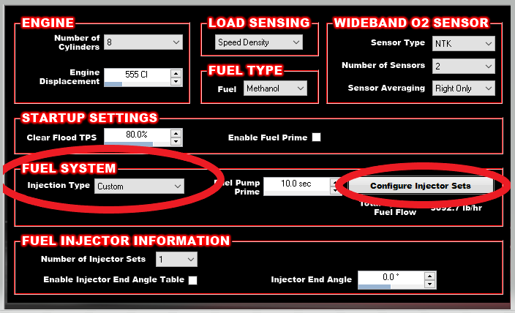

- Select the billet atomizer 700 option under the system type dropdown.

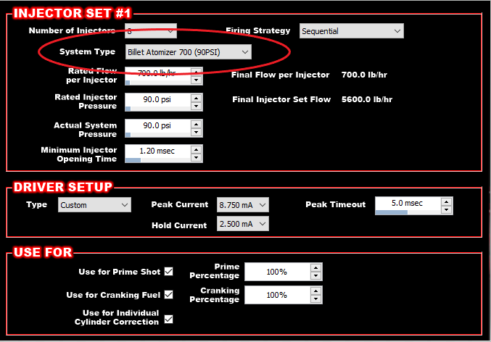

- Configure the actual system pressure and the “use for” options

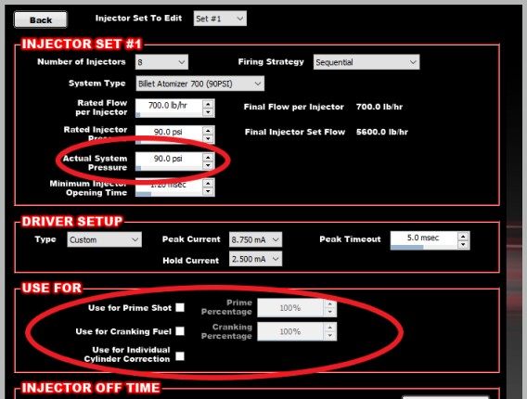

Do NOT change any of the “DRIVER SETUP” values. These are ideal for these injectors.

WIRING INFO!!!
When using 700+ lb/hr Billet Atomizer Injectors it is recommended to feed each set of eight injectors with a 10-gauge wire. This wire can be split into a pair of 14 or 16 gauge wires at the injector connector. Keep this pair of wires to less than 6 inches. If using a relay, use a minimum of a 30A relay per each set. The wiring that comes with terminated Holley harnesses is 14 gauge, so replace the relay and wiring with 10-gauge feed.

Setting up a 2nd and 3rd set of Injectors

The following tables show how to wire a second and third injector set using the custom injector strategy in V5 and Holley PN 554-142/143 external injector driver box (an external driver box is required) on an eight cylinder engine. Refer to the instructions for PN 554-142 for other wiring as well as driver box to injector wiring. This tables below are for ECU to driver box wiring (which may not be in the 554-142 instructions, refer to it for all other wiring).

Injector Set 2
ECU J2B - (PWM-) |  |  | Driver Box
Cylinder | J2B Pin |  | Cylinder | Pin
Cylinder 1 | B12 |  | Cylinder 1 | A27
Cylinder 2 | B6 |  | Cylinder 2 | A28
Cylinder 3 | B8 |  | Cylinder 3 | A29
Cylinder 4 | B21 |  | Cylinder 4 | A31
Cylinder 5 | B5 |  | Cylinder 5 | A33
Cylinder 6 | B11 |  | Cylinder 6 | A4
Cylinder 7 | B3 |  | Cylinder 7 | A5
Cylinder 8 | B9 |  | Cylinder 8 | A6
Injector Set 3
ECU J2B - (PWM+) |  |  | Driver Box
Cylinder | J2B Pin |  | Cylinder | Pin
Cylinder 1 | B24 |  | Cylinder 1 | A27
Cylinder 2 | B25 |  | Cylinder 2 | A28
Cylinder 3 | B2 |  | Cylinder 3 | A29
Cylinder 4 | B1 |  | Cylinder 4 | A31
Cylinder 5 | B4 |  | Cylinder 5 | A33
Cylinder 6 | B10 |  | Cylinder 6 | A4
Cylinder 7 | B22 |  | Cylinder 7 | A5
Cylinder 8 | B23 |  | Cylinder 8 | A6

