How to De-Pin and Re-Pin the connector used on the Fast Man EFI Cam-Sync Sensor

Background:

We use a Ford Cam-Sync sensor because it is well designed for the automotive environment, handles very high RPMs, and is a ½ revolution on and ½ revolution off design; not just a single pulse. That sensor requires a Motorcraft connector and pigtail WPT-196. This part has always been expensive for what it is – a connector with three wires attached. $35 has ballooned to $60 and even $90 each. And, I never liked that fact that all the Ford pigtail wires are black and much larger gauge than necessary. That larger wire gauge makes it difficult to attach a mating connector for the Holley ignition harness on the end of the pigtail.

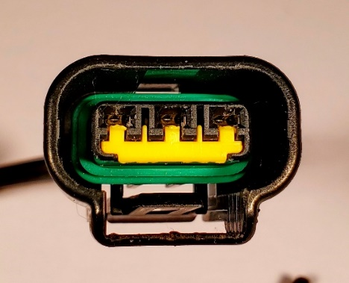
We sourced our own connector which is an exact match to the Ford version. The connector is robust and well-designed but how to remove or add pins is not obvious. This document shows you how to do it. It’s actually very simple once you know the steps.

Here is the connector from the cam-sensor end:

Tools needed:
Small blade screwdriver
Metri-Pack 150/280 crimper

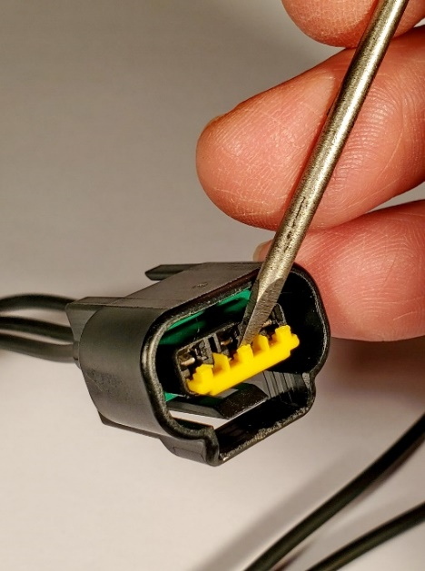
Removing a pin:

The yellow lock bar is removed by prying behind the center yellow tab. This seems counterintuitive because it looks like that might damage the yellow lock. But the lock will side out. The picture shows the yellow lock being pried out

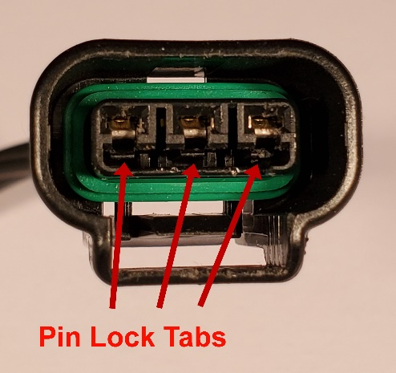
Now you can see the ends of three small plastic tabs that snap to hold the pins in place.

Using the screwdriver bend the tab away from the pin.

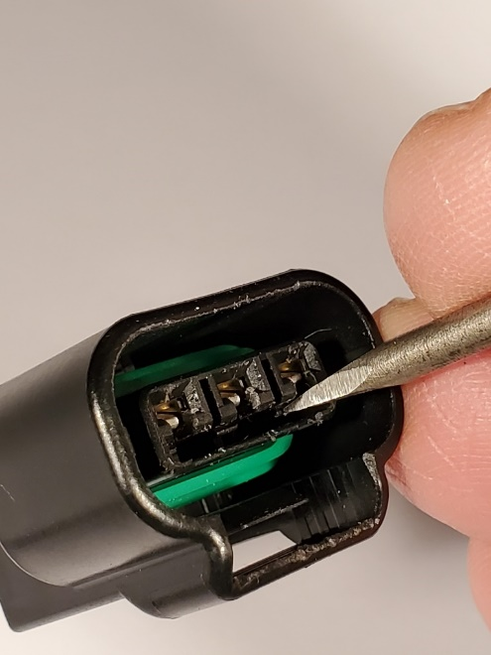
While holding the tab away from the pin you can pull on the wire and remove the pin from the back of the connector. If the wire has broken off you can push the pin out from the front but this must be done while the tab is held off of the pin.

Adding a Pin:

You should first make sure you understand the orientation of the pin when it’s in the connector body. The pin has a recess where the lock tab will engage. The connector body is designed to only allow the pin to enter one way.

Add the wire seal and crimp the pin
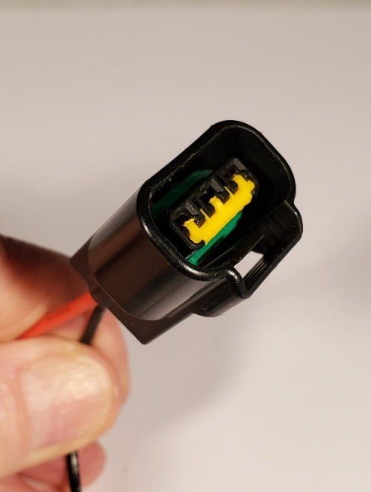
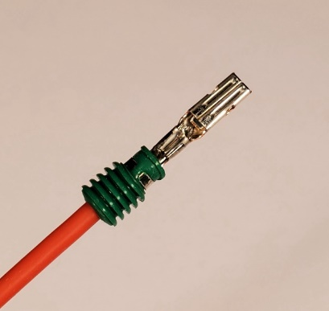

Push the pin into the housing. It should click when the tab locks. When complete, reinsert the yellow lock bar.

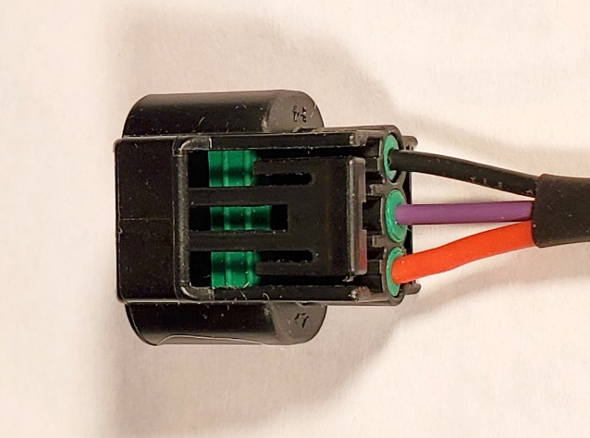
Here is the correct wire orientation of the cam sync connector:

Black = Ground
Red = Switched +12V
Purple = Cam Signal

These colors match the colors used in the Holley ignition harness.
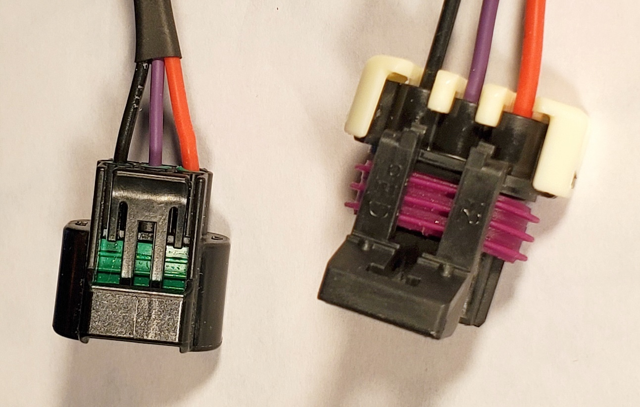

CSS-HC is a replacement connector that comes with pins and seals for $30.

CSS-HPT is a complete 12” harness that includes a matching connector for Holley ignition harnesses. (shown above) $45

CSS-HP is a cam sensor harness that does not include the Holley connector. $40

