Holley EFI V4 Software Overview

File Changes

The calibration file in V3 and earlier versions was called a “Global Folder”. The Global Folder was actually a Windows “Folder” which contained multiple files called “Individual Configuration Files” (ICF). The V4 software utilizes the same “Individual Configuration File” methodology with one notable change. The main calibration file in no longer a windows folder, and is a single file called a “Global File”. The user still can add and delete ICFs, but they are all contained within the Global File. The “ICF Library” still exists as it used to. This will eliminate the need to “zip” calibration files when emailing them.

Updating/Converting Files from Older Versions

- All V3 and earlier files, Global Folders, ICF’s, Log Files, and monitor files are not directly compatible with V4, however they can be up-converted.

- V3 and earlier Global Folders and ICFs will be up-converted when they are opened in the V4 software.

- V3 and earlier logfiles can be up-converted, but will be converted with a log file conversion tool, that will open when an earlier version logfile is opened.

Data Monitor/Logger Changes

Many new Data Monitor and Data Logger Channels were added, as well as new Internal Parameters.

- See section 9.

Range Changes

Several parameters have had their allowable ranges opened up. They include but are not limited to:

- Engine RPM- Max RPM increased from 15,000 to 20,000
- Ignition Reference changed from 0 to 360 to -360 to +360. This will allow for certain crank/cam sensor combinations to not require a swap in the engine firing order.
- Engine Coolant and Air Temperature ranges have been increased to “999”.
- Injector Flow – Increased to 2000 lb/hr
- Custom 5 Bar (Map Sensor) – This is being renamed to “Custom MAP” - When selected, it will rescale axes to 999 kPa. It has an allowable range of 0-999 kPa. This allows the use of MAP sensors up to 999 kPa (130 PSI of boost).
- TCC TPS WOT unlock raised from 100% TPS to 105%. This allows for this parameter to be set “above 100%”, which will allow for the Torque Converter Clutch to be locked at 100% TPS.
- PWM Output tables – maximum pulsewidth raised from 128 msec to 99,999 msec.
- Transmission Torque Management Timing Retard – Max retard increased from 10 to 50 degrees of retard.
- Cranking Timing – Increased from 30 to 50 degrees.
- Base Fuel Table Fuel Flow – Increased to 99,999 lb/hr

Preference Changes

- Parameters that require ignition power cycling to initialize – If a change is made or a Global folder sent that requires the ignition power/key to be cycled before starting the engine, this will be noted in two ways:
  - There will be a message that says “Ignition Cycling Required Before Start” on the bottom right
  - When a Global File is sent, a popup message will occur saying to cycle the key. This can be turned off in the Preferences.
- The checkbox in preferences that allows the user to select whether the ECU is an HP or Dominator, has moved to a new tab called “ECU Configuration” in the System Parameters. The system still auto- detects which ECU is present and updates this accordingly. (See below).
- “Display MAP as PSIA” – This previously only converted the fuel and spark table Y axes. V4 will convert all axes that were previously kPa to PSI.
- “Automatically Open Logfiles” – When checked, a logfile will automatically open after it has been saved.
- “Turn Off Crank Sensor Inductive Delay Warning” – checking this will turn off the Inductive Delay warning that pops up if the setting is over 50 usec.

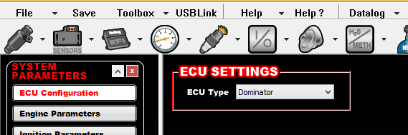

ICF Changes and Updates

1.0 System ICF

ECU Configuration Tab – NEW

This selection used to be in the Preferences area. It has now been moved to this section. It operates the same as the previous Preference selection. The user can manually select this, or it will be toggled when the system is synced to the ECU. This doesn’t change any functional parameters, but will change what I/O are shown on the Pin Map.

Engine Parameters

Load Sensing – VE Combo Mode –This is a new selection under “Load Sensing”. It allows for an engine to be run in an Alpha-N mode below a certain engine RPM and TPS, and allow for the existing “VE Based” fueling strategy to be used above that point. Selecting this will enable the Alpha-N idle fueling table to be activated in the Fuel ICF.

“Enable Injector End Angle Table” checkbox – Enables 16x16 “Injector Phasing” table (See section 1.6). Disabled state retains previous individual “Injector End Angle” as single end angle value. Also note that the range has been opened up to +/-720 degrees.

If updating an older Global Folder, the single end angle value will be retained.

Fuel System – System Type – “DI Interface” – This is a new selection that is to be used with future products. Selecting this choice opens up the “DI Target Fuel Pressure, which again is for future prodcuts.

Ignition Parameters

Rev Limiter Updates – A new rev limiter type has been added called “Spark, High Only”. This type has a single high side value. It is recommended to use this for a 2-step rev limiter and as a high side rev limiter. Other rev limiter types have had updates to them and can be adjusted to the users desired needs.

Programmable Dwell Table – An optional 16x16 coil dwell table is available for “Custom” Ignition Types. The previous, single dwell value is the standard default. To enable this table, the “Enable Dwell Table” checkbox should be checked. This will replace the single dwell value with an “Edit Table” button. The table can also be accesses and edited real-time via the “Dwell Time” selection in the System Parameters ICF dropdowns. The X and Y axes are user programmable as well, with RPM and MAP or TPS typically being the selected X and Y values.

If updating an older Global Folder, the single dwell time value will be retained.

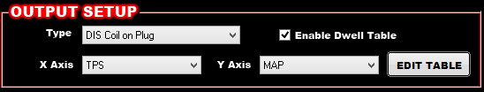

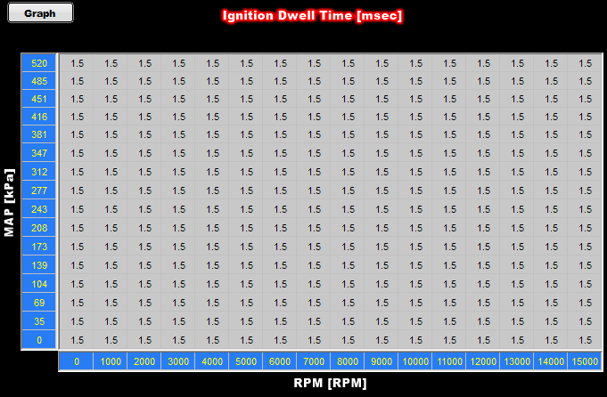

  - Sensor Scaling Warning

Warning setups are available for items (TPS, etc.) that weren’t previously there. Coolant and Air Temperature ranges have been allowed to go to much higher values. Make sure values used are within the calibration range of your sensor.

Basic I/O

TCC: The “WOT Unlock TPS” value allowed has been increased from 100.0% to 105.0%. This allows for the torque converter clutch to be locked at WOT by allowing a value higher than 100.0%.

Timing Retards: The Timing Retards have been updated per the following:

    - Third Retard Added (Retard #3)

    - All three retards have a user programmable X axis (Time or RPM). Previously these were fixed.

    - Activation can be triggered when an input is active (“Activate with Input”, which is how versions V2/3 functioned) or a new method that is activated at the release of an input (“Activate at Input Release), such as a trans brake. This will reset/stop when the input is active again, or the ignition is cycled.

Users should review these if updating an older Global Folder to V4 that used this feature.

  - Injector Phasing

Optional 16x16 injector end angle table that is active when enabled in Engine Parameters setup (Injection Type must be Multiport, and “Enable Injector End Angle Table” must be checked). Fixed X (RPM) and Y (MAP or TPS) axes are copied from Base Fuel table. “Injector Auto-Phasing” table parameters can be used to calculate and auto-populate the Injector End Table. This auto-population will center the fuel injection event around the camshaft intake lobe centerline.

For a more comprehensive overview of this feature, see the “Injector Phasing Instructions” manual.

NOTE: The injector phasing table IS allowed if using non-sequential fueling types (Bank to Bank, Paired, Untimed Sequential). If any of these selections are used, note that since there is no cylinder #1 compression stoke identification (cam sync signal) or the fact that the injectors are fired in multiples, tuning the end angle will not have the precise results that occur when sequential injection is utilized.

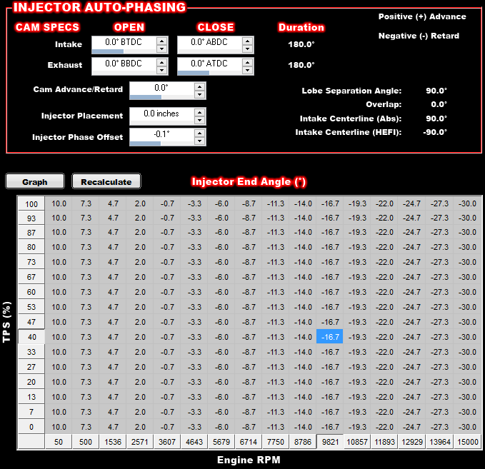

Individual Cylinder Tables: Individual cylinder fueling and timing trim control now has the option tables for each cylinder trim. The individual cylinder fuel trims utilize a 31x16 table and the individual cylinder timing trims use a 16x16 table. To use this option, select the “Use Tables” checkbox at the top of the Fuel or Timing Correction tables.

NOTE: Both the X and Y axis parameters and values are user programmable on EACH individual table. They must be entered on every table individually. To copy X and Y axis parameters AND values from one table to all others, select the “Copy Axes to All Cylinders” button which is at the top of all screens.

IMPORTANT NOTE!!!!! – THE TIMING CORRECTION CONVENTION HAS BEEN REVERSED FROM PREVIOUS SOFTWARE VERSIONS. IN V4 SOFTWARE, A POSITIVE VALUE ADVANCES TIMING, A NEGATIVE VALUE RETARDS TIMING. NOTE THAT WHEN AN OLDER GLOBAL FOLDER IS UPDATED, THE VALUE WILL BE SWAPPED AUTOMATICALLY SO THAT THE PROPER CONVENTION WILL BE MAINTAINED.

If updating an older Global Folder, the single trim values will be maintained. The sign convention (+/-) will be swapped, in order to not change the calibration. See “Important Note” above.

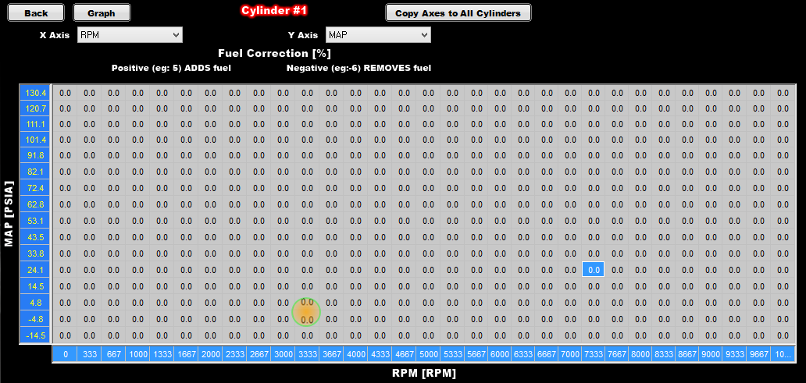

NOTE CHANGE IN CONVENTION!

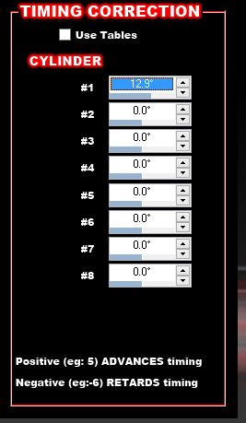

2.0 Nitrous ICF

A number of items were added to the Nitrous ICF. Four additional stages were added as well as five more Inputs and four more GPO’s, as well as new functionality.

Also note a new feature that indicates which stages are activated, and of these, any that are disabled. If using the menus on the left, an active stage will have a green dot. A stage that is activated, but disabled, will have a grey dot. If using the dropdown menus at the top active stages will have a checkmark next to them, while disabled, staged will have the word “disabled” next to them.

Additional Stages

    - Stages 5-8: Four additional stages have been added. Stages 1-8 all have identical functionality.

Nitrous Parameters

    - Inputs 4, 5, 6, 7, 8: These are additional to the previous three. They retain the same options as well as two new additions that will be helpful for bracket racers using nitrous. See section 2.4.4 for more information.

    - Dry Fuel Delay: The single dry fuel delay in the “Nitrous Parameters” has been removed. A dry delay has been added to each individual stage.

When updating a previous version global folder, the single dry fuel delay will be populated in each individual stage.

  - GPOs

GPO’s 5-8: Four additional GPO’s have been added. These are additional to the previous four.

All Stages

The nitrous stages have had some re-layout in the software, as well as some new features added.

2.4.1 Stage X Setup 2.4.2
Previous parameters have been grouped into this area, including an individual Dry Fuel Delay for each stage. Each dry fuel delay can be custom set for each stage.

When updating a previous version global folder, the single dry fuel delay will be populated in each individual stage. You can now update each per stage.

    - Activation/Deactivation

Previous parameters as well as new parameters are in this area. Some previous parameters have been renamed as noted below, with the functionality not changing, just their name.

Minimum RPM: Previously named “RPM Trigger”. Nitrous will not be allowed to be activated below this engine speed.

Maximum RPM: Previously named “RPM Cutoff”. Nitrous will not be allowed to be activated above this engine speed.

Stage Activation Delay: Previously named “Delay”. This is the amount of time a stage activation time will be delayed, once all other activation conditions are met.

Stage Duration: This is a new parameter. This is used to turn off a stage during a pass. Typically used for bracket/index racing. After a stage is activated, it will turn off after this time. The checkbox must be checked for this feature to be active.

Note that the new “Override Stage Duration” feature in the “Inputs” can override this time, and turn the stage back on, while this input is active.

Inputs

The Inputs area has 5 more inputs (4-8) added. There are two new choices in all of them as follows. These are typically used by bracket/index racers.

      - Override Stage Duration – This input will turn a stage back on while this input is active (must remained “pushed/active”), when the stage has been turned off by the “Stage Duration” parameter.

      - Cancel (until reset) – This input will turn a stage off while this input is active (must remained “pushed/active”), when the stage is being commanded on otherwise.

Also note that Input 3 has an option no other stages offer called, “Timed Disable”. This will bring up a variable called “Input 3 Reactivation Time”. When an input is applied to Input 3, selected stages will turn off and turn back on based on the Reactivation Time. This can be used to turn a stage off on a shift, etc. This was a feature present in V3.

Pedaling Control

Pedaling Control is an area that determines what each individual nitrous stage will do if the vehicle is “pedaled”, meaning the throttle/TPS movement deactivates and reactivates the nitrous. This area integrates the previous “Pause Enabled” feature and adds some other options.

Pedaling Strategy: There are three choices as follows:

None (Full Timer Reset) – If the car is pedaled, the stage timers will reset back to time = 0 (zero). This would be the same as not checking the Pause Enabled in previous software versions.

Pause Enabled – If the car is pedaled, the stage timers will freeze, and restart at this time once the nitrous is reactivated. This would be the same as having the Pause Enabled checked in previous software.

Programmable Restart – This is a new option. If the car is pedaled, one of two things will happen:

- If the Stage Timer is LESS than the “Stage Restart Time”, the nitrous will restart at the frozen Stage Timer times (same as the “Pause Enable” feature).

- If the Stage Timer is GREATER than the “Stage Restart Time”, the nitrous will restart at the Stage Restart Time value.

Timing Retard

There is one new parameter in the Timing Retard area as follows:

Retard Hold After Deactivation: This parameter dictates how long a stage timing retard will be held, after a stage is deactivated. This was fixed/hard-coded to 0.5 seconds in previous versions. This is a safety to keep the timing retarded until all the nitrous has evacuated from an engine.

When updating a previous version global folder, the hardcoded 0.5 seconds will be populated in each individual stage.

  - Advanced Tuning ICF

The Advanced Tuning (AT) ICF is a new ICF that allows for a variety of operating functions to be modified based on inputs and outputs. It offers significant options and flexibility for engine tuning, power management, and many other items. There are four different table setups offered, which all allow the same tuning options. They consist of the following:

    - 1D Tables – There are eight individual tables, each consisting of a 1x16 table.

    - 2D Tables – There are eight individual tables, each consisting of a 16x16 table.

    - 1D Per Gear Table – There are eight tables, each consisting of up to eight 1x16 tables. Up to eight gears are available.

    - 2D Per Gear Table – There are eight tables, each consisting of up to eight 16x16 tables. Up to eight gears are available.

Setup

    - ear Based Setup
The setup area is utilized if either the 1D or 2D Gear Tables are used. If neither are used, nothing has to be configured. If Gear Tables are used, select one of three methods. If an electronic transmission is being controlled by the ECU, select “TCU Input”. If the transmission has a single switched input to trigger shift events, select “Individual Inputs”. If engine speed drop is select “RPM Drop” for the shift recognition type.

If “RPM Drop” is used, the AT Gear will be estimated by examining the engine speed. If the engine speed goes above Min RPM for Shift Detect and then drops by more than RPM Drop for Shift Detect the AT Gear variable will be incremented by one until it reaches Number of Gears.

If the engine speed drops below the value in Automatic Gear Reset RPM for a time greater than Automatic Gear Reset Time, the AT Gear will automatically be reset back to 1 and held until you go back above the Automatic Gear Reset RPM. If you check the box for Manual Gear Reset then asserting the Manual Reset input will reset the AT Gear back to 1.

If “Individual Input” is used, the AT Gear will be incremented by active edges of the Man. Shift Input until it reaches Number of Gears. If the engine speed drops below the value in Automatic Gear Reset RPM for a time greater than Automatic Gear Reset Time, the AT Gear will automatically be reset back to 1 and held until you go back above the Automatic Gear Reset RPM. If you check the box for Manual Gear Reset then asserting the Manual Reset input will reset the AT Gear back to 1.

All Tables (1D, 2D, 1D per Gear, 2D per Gear)
To use a table, the Enable Table checkbox box must be selected. Next enter a description for the Name of the table that makes identification of the table easy. This will show up on the Data Monitor and Data Logger as the name entered. This value will be indicative of the table modifier value.

There are options for certain Table Types to inhibit closed loop or fuel learning when that Advanced Tuning table is active. Select the checkboxes for “Inhibit CL Compensation when Activated” or “Inhibit Base Fuel Learn when Activated” to inhibit these operations.

Next, enter the Table Type, which will select the modifier. Note the following nomenclature on these:
      - “Offset” – Adds or subtracts a raw value from the modified parameter

      - “Multiplier” – Performs a percentage increase or decrease to the modified parameter.

Important Note: If multiple “Multiplier” tables are used for the same function, they will be multiplied together. For example, one might be using a table for E85 compensation and another for fuel pressure compensation. If the final fuel flow is 100 lb/hr, and one table is adding 25% more fuel and the other taking out 10% the math works out to: 100 lb/hr * 1.25 * .90 = 112.5 lb/hr.

Note that how this value affects the parameter is indicated in the software above the graph. The “neutral” value that does not perform any modification is specified.

The following items can be modified:

      - Fuel Flow Offset – Adds or subtracts fuel to the final fuel flow value. Note that the final fuel flow includes AE fuel, nitrous enrichment, and all other fuel modifiers, etc. It also modifies cranking fuel.

      - VE Based Fuel Flow Offset – Adds or subtracts VE% to the final VE value.

      - AE Fuel Flow Multiplier – Multiplies the final AE Fueling value.

      - Fuel Flow Multiplier – Multiplies the final fuel flow (no matter what type of fueling strategy is used, whether it be lb/hr or VE based) by this amount. Note that the final fuel flow includes AE fuel, nitrous enrichment, and all other fuel modifiers, etc. It also modifies cranking fuel.

      - Timing Offset – Adds or subtracts timing to the final timing value.

      - Target Air/Fuel Ratio Offset – Performs an offset to the target A/F ratio. NOTE: If this modifier is employed, the final fuel flow value is offset by the ratio of the base target air/fuel ratio, and the offset performed. For example, if the base target air/fuel ratio is 12.0:1, and an offset of -1.0 is performed (effectively richening the target to 11.0), the final fuel flow will automatically increase by 8%.

      - Target Air/Fuel Ratio Multiplier – Multiplies the Target Air/Fuel ratio by this value.

      - Closed Loop Compensation + and – Overrides – When this table becomes active, the tuner has the ability to override the base Closed loop Compensation Limits % table with this new value.

      - Target Idle Speed Offset – Adds or subtracts to the target idle speed value.

      - IAC Position Offset – Adds or subtracts to the current IAC Position.

      - Boost Offset – Adds or subtracts to the target boost level. The “target boost” will be either dome pressure or actual boost depending on how the boost control is set up in the software.

      - Nitrous Stage 1-8 Offset – This will offset the nitrous percentage by the value entered for the stage specified.

      - Drive By Wire Offset – This will offset the commanded drive by wire throttle body position. Note that the following maximum limits will be allowed for the first three Pedal Position cell values:
• 0% - 25%
• 7% - 35%
• 13% - 45%

Limits: The throttle can be DECREASED by 100%, however a limit of 5% is allowed to be added.

      - Cylinder #1 - #8 Timing Offset – Offsets individual cylinder timing based on this value.

      - Cylinder #1 - #8 Fuel Multiplier – Multiplies final individual cylinder fuel values based on this value. If there are trims in both the System Parameter trims as well as the Advanced ICF section, they will be multiplied together. For example, if the trims are 8% and 5% for a single cylinder, it will equate to 1.08 * 1.05 = 1.134, or 13.4%.

      - Injector End Angle Offset – Offsets the base “Injector End Angle” value

      - Cranking Fuel Multiplier – Multiplies the base cranking fuel number by this value.

Finally, select the X and Y (for 2D tables) axis parameters. The axis break points are fully user-editable.

There are many options available that can be used for the X and Y axes including basic engine sensors, multiple operational parameters, Advanced Tuning ICF Tables values, Input / Output ICF sensor input variables, Nitrous, Boost Control, Transmission, Water Meth, Drive By Wire, and other items.

Activation
These functions can be activated based on a wide range of inputs and outputs. The tables can be activated based on the release of an input such as a trans-brake. They can also be activated base on a switched or sensor input. A tuner/user should possess a high level of knowledge to use these functions. If none of the activation conditions are selected, the particular Advanced Tuning table will be active all the time. Note that each activation table must be set up for every table, even if the activation conditions are all the same.

Select the AT Launch Input Enabled Checkbox if this functionality is desired. If checked, an input must be

pin mapped. When this input is active and released (such as a trans brake), the table will be active. Once the table is deactivated, this input must be active and released to enable/start the table again.

The Time Delay to Start, if enabled will delay the activation of this table when the table is active. This time will be added after either/both the AT Launch Input is used, as well as the “Activation” parameters are met.

The Activation parameters, if enabled, provide methods of activation conditions for the table. The Switched Enable provides a dropdown of choices that allow table activation when they are either in an enabled or disabled state. Note that some of the dropdown choices can be items that have variable values, not just items that are “on or off”. If one of these are selected, they will allow activation whenever they are in an “active” state. The Advanced Enable allows table activation by a parameter that allows the user to select the values
above/below as well as a deactivation value. If both are enabled, the AND/OR value can be chosen to indicate whether one or both conditions have to be active for table activation.

The table/graph is where the particular tuning modifier is edited. 1D tables are shown with a table and graph. 2D tables are shown with a table, with a graph button available. The X and Y axis values may be edited as needed as well.

2D Tables

    - 16x16 table. Same as 1D tables, except a Y axis variable is selected.

1D Per Gear Tables

    - Same as 1D table, except one table is available for each gear

2D Per Gear Tables

    - Same as 2D Table, except one table is available for each gear

Inputs/Outputs

There are three Inputs that can be activated and need to be pin mapped.

    - AT Shift – This is used for gear based setup if the “Shift Recognition” is set to “Individual Input”. This is used to increment a gear change.

    - AT Launch – This is used if the “AT Launch Input Enabled” checkbox is selected. This will activate the specific table once this input is released (such as a trans brake).

    - AT Manual Reset – This is used for gear based setup (if the “Shift Recognition” is set to “RPM Drop” or “Individual Input”. Once activated, the Gear will reset to Gear “1”.

4.0 Traction Control ICF

Setup

    - “System Type” added – allows user to select from TC1/TC2 selection, or new Profiler or Profiler with Smart Drop

Inputs/Outputs

    - “Profiler Input” and “Smart Drop Input” added.

5.0 I/O ICF

Inputs

    - Nomenclature Change – The previous “TYPE” dropdown names were changed:
– DIGITAL SPEED to DIGITAL SPEED/FREQ
- IPU SPEED to IPU SPEED/FREQ

    - Added new DIGITAL SPEED/FREQ types:
      - GM Flex Fuel – Allows the use of 50-150 Hz flex fuel sensors. Will read in % Ethanol content. A common part number for a cost effective compatible sensor is Continental PN 13577379. The pigtail for this sensor is GM PN 13352241.
This sensor should be wired in the following manner: Pin 1 (Vcc) – Connect to switched voltage (12V)
Pin 2 (Gnd) – Connect to a solid ground
Pin 3 (Out) – Flex fuel sensor input to ECU. Connect to whatever ECU this is mapped to.

This input also must be connected to a 5v wire via a 10k (10,000) Ohm pullup resistor. Any 10k Ohm resistor can be used. See the diagram below. Tie one end of the resistor to the flex fuel sensor input and the other to one of the ECU 5v lines. These pins are shown on the diagram below.

To configure the flex fuel operation, see the examples in the addendum at the end of this document.

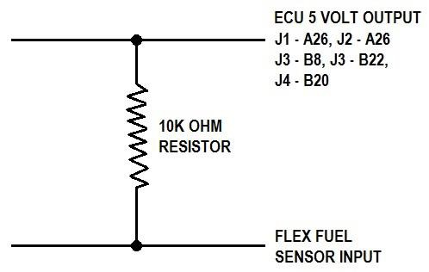

- Frequency – Will indicate/record frequencies up to 20,000 Hz
- Custom Frequency – Allows for devices with variable frequency outputs to be set up using a calibration table.

    - Added new IPU SPEED/FREQ types
      - Frequency
      - Custom Frequency

Outputs

Some very useful additions have been made to the Outputs section

    - Added “AND/OR” to the Switched and Sensor Input Triggers. This allows for the option of both (AND) or either (OR) of the Switched and Sensor input triggers to be required to activate an output.

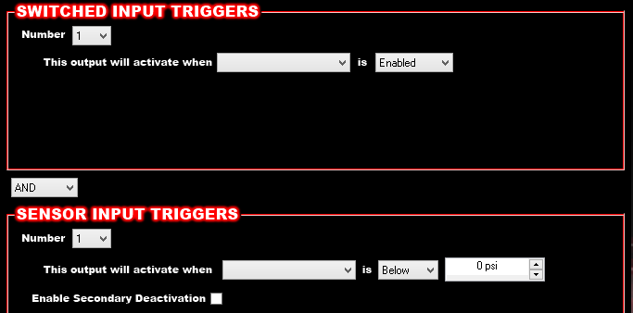

When updating a previous version global folder, the “AND” will be automatically populated as was previously the case.

    - There are new options available that can be selected for the “Sensor Input Triggers” for an output. These include some new engine operational parameters and Advanced Tuning ICF Tables values.

    - Timer option – There is now a timer option for an output. Each timer function can be individually enabled. They are the following:

“Start Activation Delay” – Once all the Switched and Sensor Input Trigger conditions are met, this delay will be used before the output is performed. This is a “one time” delay. It will only re-occur once the activation conditions (Switched and Sensor Input Triggers) drop out and re-occur.

“Active Time” – This is the length of time the output will be active for. If/once this time is met, the output will de-activate. Once this time is met, the timer will only restart once the activation conditions (Switched and Sensor Input Triggers) drop out and re-occur, OR if the “Repeat” checkbox is select, and after the “Inactive Time” occurs. If the “Repeat” is option is selected, the output will starts WITHOUT
the “Start Activation Delay” entering into play..

Repeat Checkbox - This checkbox will enable the “Inactive Time” function.

“Inactive Time” - This parameter will be only available if the “Repeat” checkbox is selected. It will be the time that the output will be turned OFF, before it starts again and remains on for the “Active Time”.

Note that a diagram of how the output will operate depending on how it is configured will be show for each combination of selections in the software.

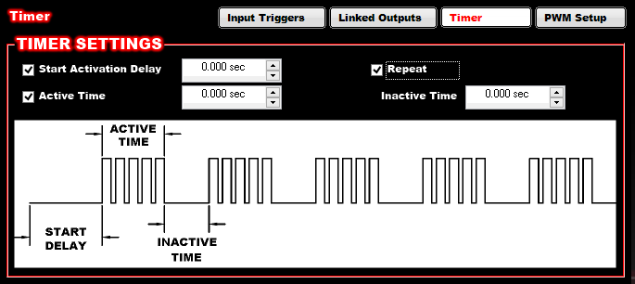

The following are some examples of how the timer function can be set up. Note that these can be
+12V or Ground Outputs. All examples shown are +12V.

+12V Output with Start Delay, Active Time, No Inactive Time

PWM+ Output with Start Delay, Active Time, No Inactive Time

+12V Output with Start Delay, Active Time, and Inactive Time

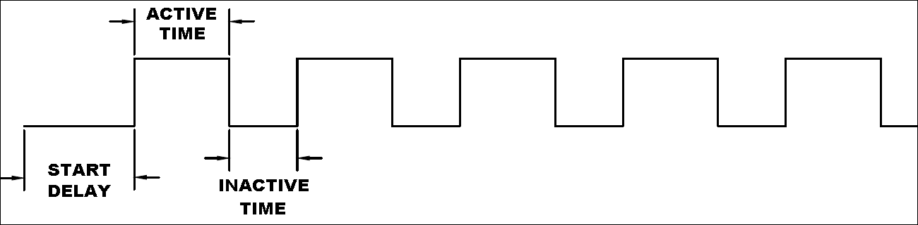

PWM+ Output with Start Delay, Active Time, and Inactive Time

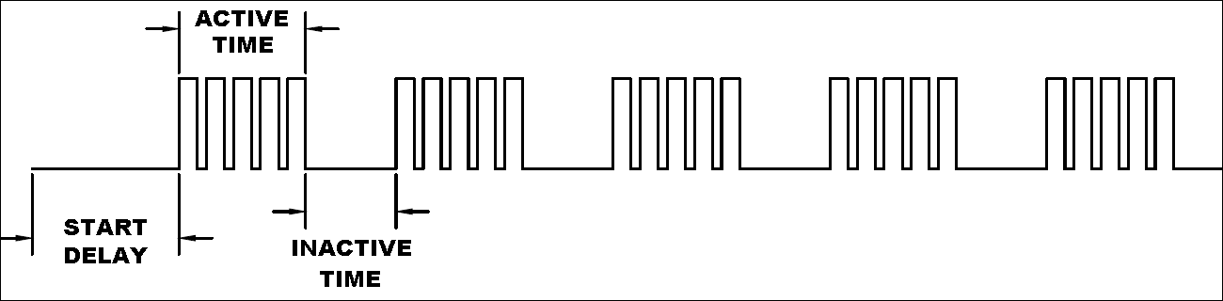

+12V Output with Start Delay, No Active Time, No Inactive Time

PWM+ Output with Start Delay, No Active Time, No Inactive Time

+12V Output, no Delay, with Active Time, no Inactive Time

PWM+ Output, no Delay, with Active Time, no Inactive Time

+12V Output, no Delay, with Active Time, with Inactive Time

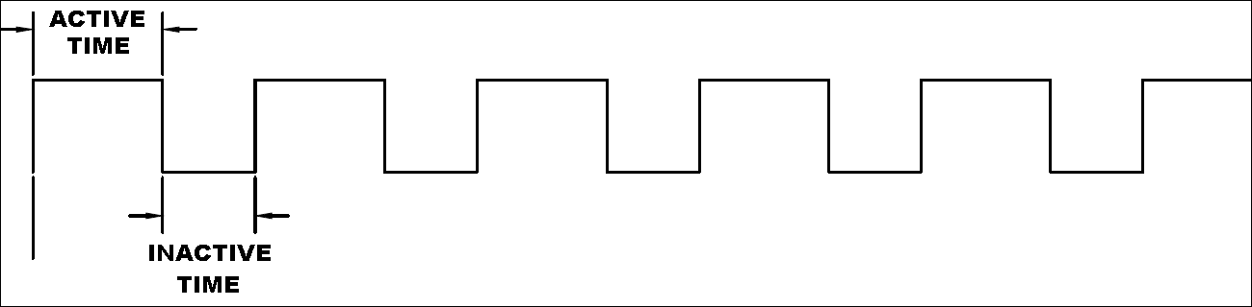

PWM+ Output, no Delay, with Active Time, with Inactive Time

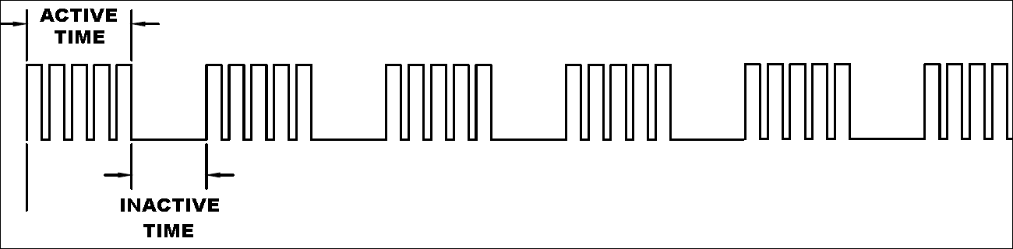

+12V Output, no Delay, no Active Time, no Inactive Time

PWM+ Output, no Delay, no Active Time, no Inactive Time

6.0 Boost ICF

Boost ICF Changes

    - Boost vs Gear & Boost vs RPM - Changed “Number of Gears” from 6 to 8.
    - Boost vs Speed – X speed axis now user programmable

7.0 Fuel ICF

A/F Offset Table

The A/F ratio offset table has been modified in the following ways:
    - The rich/lean convention has been changes such that a positive value LEANS the target A/F ratio
    - Positive and negative values are both now allowed.

When updating a previous version global folder, the sign convention will be changed from positive to negative automatically, so that the tune isn’t changed.

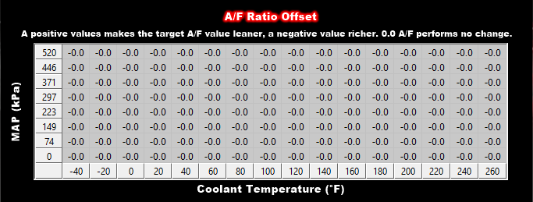

  - Base Fuel Table – Conversion

The “Conversion” checkbox on the base fuel table as well as graph will toggle a fuel flow based table to VE or visa-versa. A new functionality is that you can edit the table when it is in its converted mode.
This can be very advantageous and allows smoothing and editing in either fuel flow or VE fueling modes.

Sensor ICF

    - The previous MAP sensor selection of “Custom 5 bar” is now renamed to “Custom MAP”. It allows for any MAP sensor up to 999 kPa (130 PSI). Selection of this sensor will autoscale the MAP axes to 999 kPa.

    - Custom coolant temp allows higher temperature range (999F) than was previously (260F) allowed. Make sure that the sensor you are using has accuracy in the ranges you specify. (Standard sensors are also allowed to go to 999F in the Sensor Scaling area as well)

    - Custom MAT temp allows higher temperature range (999F) than was previously (275F) allowed. Make sure that the sensor you are using has accuracy in the ranges you specify. (Standard sensors are also allowed to go to 999F in the Sensor Scaling area as well)

9.0 New Data Monitor and Logger Parameters

Estimated VE – This parameter was introduced in V3. This parameter estimates the VE taking into account what the closed loop fuel trimming is performing. If you are manually tuning an engine, you can use this value to help in more quickly tuning the base VE table.

Timing Retard #3 – This indicates the status (on/off) of the new Timing Retard #3. Note that the X axis time value (as well as Timing Retards #1 and #2) be displayed via the use of new internal parameters called “System_TimingRetard#1/2/3_Time”

Base Fuel lb/hr – Indicates the base fuel value (lb/hr) from the base fuel map. All modifiers are not included Base Fuel VE – Indicates the base fuel value (VE) from the base fuel map. All modifiers are not included.
Base Timing – Indicates the base timing value from the base timing table. All modifiers are not included. Base Target AFR – Indicates the base target air/fuel from the target A/F table. All modifiers are not included.
Base Ign Dwell – Indicates the base ignition dwell, that is either from the user input single dwell value, base dwell table, or hard coded from the Ignition Type selected. This is the nominal value at 13.8 battery volts. More or less voltage will change this value, which is indicated by the “Vol Comp Ign Dwell” internal parameter.

Vol Comp Ign Dwell – This is the actual coil dwell, which is based on the Base Ign Dwell, and modified by battery voltage.

Inj End Angle – Indicates the injector end angle, whether using the single value, or the base table. If the end angle offset in the Advanced ICF is being used, this will be included.

ECU Log Trigger – Indicates if internal ECU logging is active. Timing vs Air – Indicates the Timing vs. Air Temp modifier value.
Timing vs Cool – Indicates the Timing vs Coolant Temp modifier value. Status 1-8 (Eight Parameters) – These are not used at this time.
Injector #1-12 PPH – (Twelve Parameters, Injectors 1 through 12) – Indicates the flow (in theoretical lbs/hr) that each injector is delivering. This takes into account the individual injector cylinder trims.

Injector #1-12 PW - (Twelve Parameters, Injectors 1 through 12) – Indicates the injector pulse width (msec) of each injector. This takes into account the individual injector cylinder trims.

Cyl #1-16 Fuel Cor – (Sixteen Parameters, Cylinders 1 through 16) – Indicates the individual cylinder fuel correction (%) of each injector.

Cyl #1-16 Timing Cor - (Sixteen Parameters, Cylinders 1 through 16) – Indicates the individual cylinder timing correction (degrees) of each injector.

Boost Master Enbl – Indicates the status of the boost master enable input. Boost Man Shift Inp – Indicates activation of the boost manual shift input. Boost Fill Sol DC – Indicates the boost control fill solenoid duty cycle.
Boost Vent Sol DC – Indicates the boost control vent solenoid duty cycle.

W/M Sol 1 Flow – Indicates the theoretical flow from water/meth injection solenoid #1. W/M Sol 2 Flow – Indicates the theoretical flow from water/meth injection solenoid #2.
W/M Flow Total – Combined theoretical flow from water/meth solenoids #1 and #2. W/M Sol 1 DC – Indicates the duty cycle of water/meth injection solenoid #1.

W/M Sol 2 DC - Indicates the duty cycle of water/meth injection solenoid #2.

N20 Stage 5-8 – (Four Parameters, Nitrous stages 5 through 8) – Indicates the % activation of nitrous stages five through 8.

GPO 5-8 – (Four Parameters, GPO’s 5 through 8) – Indicates the output values from GPO’s 5 through 8. N20 Input #4-8 (Five Parameters, Inputs 4 through 8) – Indicates the input status of inputs 4 through 8.
N20 Dry Fuel #1-8 (Eight Parameters, Nitrous Stages 1 through 8) – Indicates the dry fuel flow (lbs/hr) of each individual nitrous stage.

N20 Tmg Mod #1-8 (Eight Parameters, Nitrous Stages 1 through 8) – Indicates the timing retard of each individual nitrous stage.

N20 Timer #1-8 (Eight Parameters, Nitrous Stages 1 through 8) – Indicates the value of each nitrous stage timer. A negative value indicates the stage is not active, but counting down to activation. A positive value indicates the stage is active.

Trans Man US Input – Indicates a manual upshift input to an electronic transmission. Trans Man DS Input – Indicates a manual downshift input to an electronic transmission. Trans Auto/Man In – Indicates the status of the transmission Auto/Manual mode input. Diag #11-20 – New diagnostic parameters that are not being used at this time.
Advanced ICF Parameters:

AT Launch Input – Indicates the state of the launch input. AT Shift Input – Indicates a shift input.
AT Manual Reset – Indicates a manual gear reset. AT Gear – Indicates the indicated gear.
AT 1D #1-8 – (Eight Parameters) – Note that these will be renamed to whatever the “Name” is in the Setup area. These will be show the value and units of the parameter being modified.

AT 2D #2-8 – (Eight Parameters) – Note that these will be renamed to whatever the “Name” is in the Setup area. These will be show the value and units of the parameter being modified.
AT 1DGear #1-8 – (Eight Parameters) – Note that these will be renamed to whatever the “Name” is in the Setup area. These will be show the value and units of the parameter being modified.

AT 2DGear #1-8– (Eight Parameters) – Note that these will be renamed to whatever the “Name” is in the Setup area. These will be show the value and units of the parameter being modified.

New Internal parameters:

AT_1D#1-8_Xaxis AT_2D#1-8_Xaxis AT_1DperGear#1-8_Xaxis AT_2DperGear#1-8_Xaxis AT_Gear
System_TimingRetard#1-3_Time Trans_TargetGear Trans_AdvancedTorqueTimingTriggered Trans_AdvancedTorqueTiming Trans_BrakeswitchLockup Trans_ShiftSolenoidA12 Trans_ShiftSolenoidB23 Trans_ShiftSolenoid32 Trans_LineTempStatusLockup Trans_TpsStatusLockup

10.0 Calibration Updater and Calibration File Comparison

V4 software includes a utility to convert previous V2/V3 calibration files (Global Folders) and ICF’s to V4 versions as well as a utility compare two V4 calibrations. These will automatically be installed when the V4 software installed. To access them, in Windows 8, go to the Start screen and then the Apps screen and they should be under the Holley V4 area. Windows 7 and 10 should find them under the Start button. The Calibration Updater is called “Holley EFI V4 GCF Conversion Tool”. The Comparison Tool is called “Holley EFI V4 GCF Comparison Tool”.

Global Folder and ICF Converter

The HEFI V4 GCF Converter can convert both V2/V3 Global Folders and V2/V3 ICF’s to V4 versions in one quick conversion. First open the program, it will look like this:

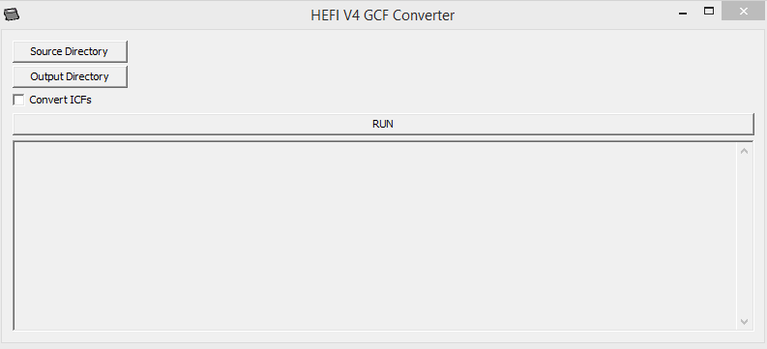

Next, select a Source Directory and then an Output Directory. You can create a new Output Directory during this process if desired. If you click the “Convert ICF’s” checkbox, all ICF’s of the ICF’s contained within the Global Folders will be converted into V4 ICF’s. These will be contained in the Output Directory in folders with the Global Folder name. Note that if you have directories within the Source directory, Global Folders and ICF’s within, will be converted as well, with the directory structure maintained in the Output Directory. Once

you select the Source Directory and the Output Directory, select the “Run” button and the conversion will take place.

HEFI GCF Comparer

V4 software includes a calibration file comparison tool. Once the program is opened it will look like this:
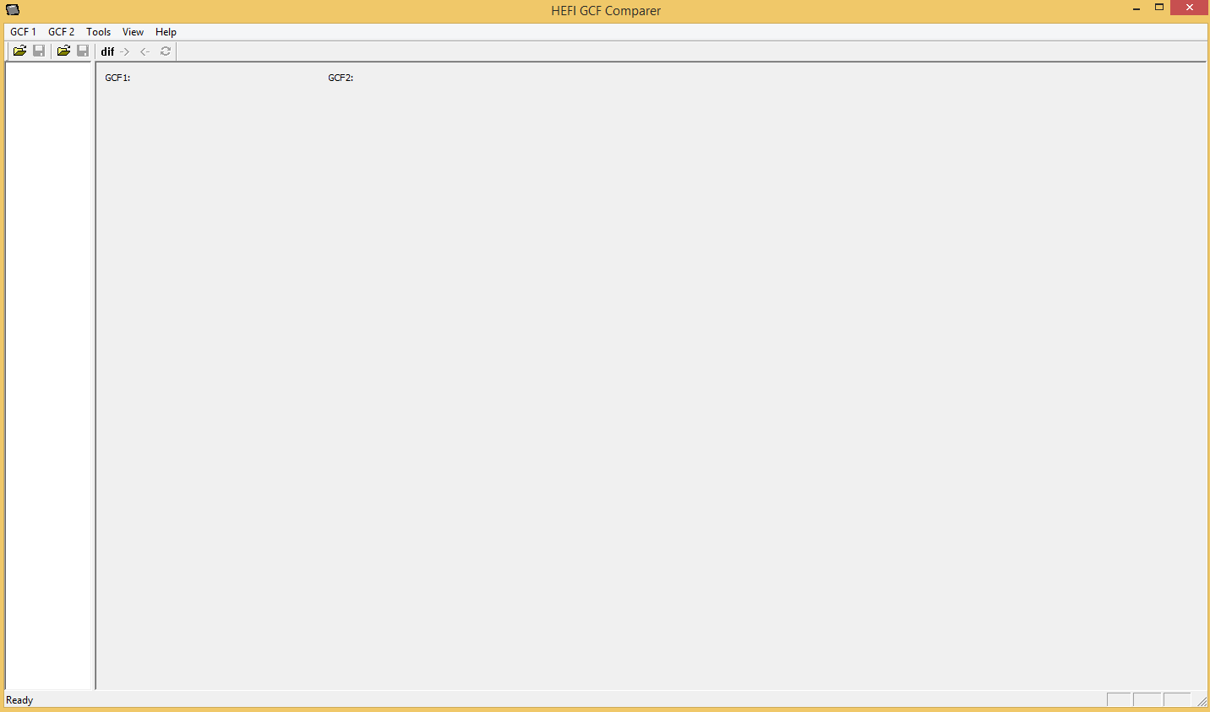

Click on the “GCF 1” tab and select “Open”. Select a calibration. Then click on the “GCF 2” tab and select open. Select a calibration. Once both are selected, a selection tree will appear on the left. It will show all of the different ICF’s. If an ICF is bold, it means were are differences between the two calibration. If not bold, they are the same. Click on the “+” sign to open up the tree to move deeper into the comparison. If an item appear bold, it means there are differences. Once you reach a table, select it. The table will open and show the values of both tables. Different tables have different methods of showing the comparison. If you want to only show the tables with differences, select “Tools” and select the “Show Differences Only”.

The program has the ability to copy tables from one calibration to another. You can copy multiple tables/complete ICF’s at one time. To copy a single table, open just that table, which will be at the end of the tree. Select “Tools” and then either “Copy from File 1 to File 2” or “Copy from File 2 to File 1”. To copy multiple screen or an entire ICF, place the cursor on the tree structure at a higher level in the tree. The select the copy functions. All parameters below this level will be copied. The copy is not transferred permenantly until it is saved. To save a file, click the save icons (small disk). There is one for both File 1 (left) and one for File 2 (right) that must be done for either file. You can also select the GCF1/GCF2 dropdowns and perform a Save or a Save-as.

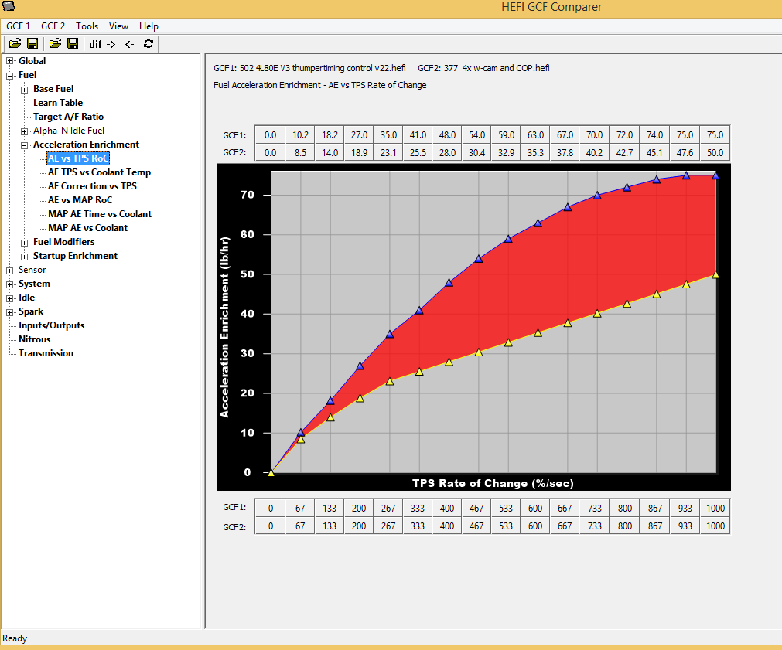

HEFI GCF Comparer - D

GCF 1 GCF 2 Tools Vit!N He p
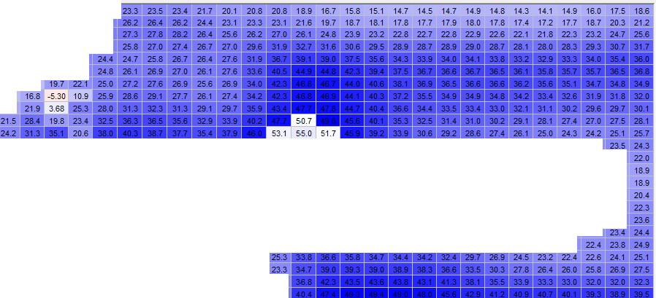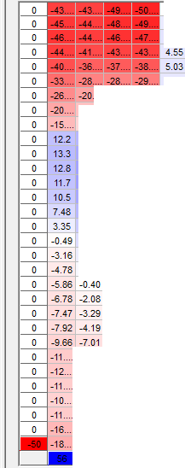liiil I liiil dit > <· :::
1±1-- Global
EJ..fuel
($l· fuel Table Size Table
i...Learn Table Target Alf Ratio
iiJ-Alpha-NIdle Fuel
EJ..Acceleration Enrkhment L AEvs TPS RoC
AE TPS vs Coolant Temp
i AE Correction vs TPS L AE vs MAP RoC
MAP AE Timevs Coolant MAP AE vs Coolant
[$..Fuel Modifiers
l±J..Startup Enrkhment

GCF1: 502 '1.80E V 3 timingcontrot v22.hefi GCF2:377 4xw-cam and COP.hefi Base Fuel -Table

r GCF Base r GCF2Base r Delta (.' Percent
....
0.07 8.17 16.6 19.1 20.7 16.7 15.8 15.1 14.5 14.7 14.9 14.8 14.3
3.77 11.1 19.4 22.5
12.0 20.4 5.1
2
5.22 24.3
11.7 20.9 23.1 24.1
12.4 21.8 24.0
4.67 11.2 20.2 23.3
-20 -21 8.32 12.6
.. -13... -12.. -15.... 13.2
.. -9.03 -8.37 -12.... 17.1
14.1 15.3 16.8
16.6 18.2 20.0
17.9 20.8 21.4 23.4 22.3

1±) Sensor | 18.3 22.3 20.3 20.1 22.3 |  | 21.1 20.1 19.4 19.5 21.0
-- System | 16.8 22.0 20 5 19.5 21.0 22.6 |  | 18.0 16.8 16.2 16.3 17.8
l±J.. ldle | 13.9 20.4 21.6 20.5 22.0 22.9 | 22.3 | 17.4 16.3 15.7 16.0 17.6
1±].. Spark | 10.4 17.6 20.3 20.3 21.8 22.4 21.1 22.3 22.3 20.8 | 17.1 16.9 | 19.0 17.9 17.4 17.7 19.3
Inputs/Outputs | 6.63 13.8 16.7 18.6 22 1 22.3 17.2 17.2 16.7 15.4 | 13.2 13.6 | 21.0 20.0 19.5 19.7 21.3

Nitrous
.. Transmission
3.47 9.89 12.7 16.3 22.0 21.4 10.1 735 9.70 10.7 10.2 11.4 22.4 21.4 20.9 21.1 22.6
1.35 6.97 9.19 13.7 20 9 19.5 5.31 0.94 3.76 7.30 8.55 9.42 232 22.3 21.7 21.9

-10.... -8.66 -8.30 -3.48 5.22 8.89 -0.82 -2.77 2.85 5.61 2.31 -0.37 -0.27 10.6 -52.3 53.7 53.3 52.6 51.8 .
-
.....
----------

4.28 5.96 10.5 18.7 19.0 5.01 -0.24 1.27 3.89 5.42 6.04 9.81 23.1 22.7 22.1
1.85 3.16 7.16 14.7 15.8 5.18 0.46 0.87 2.06 2.20 1.94 4.13 13.1

0.21 1.12 3.60 9.01 10.5 3.21 0.33 1.03 0.75 -1.19 -3.42 -2.56 7.53
-1.01 --0.59 0.64 4.70 6.65 1.18 0.16 2.20 1.61 -2.43 -5.81 -4.56 6.68 23.1
-4.98 -5.58 -4.71 -0.36 2.32 -2.36 -0.23 5.71 629 054 -4.01 -3.59 7.93 (.aa
.. -10.... -8.35 -8.30 1.08 1.26 -4.11 -1.84 5.73 7.46 1.67 -2.44 -2.22 9.03 tiii) 50.9
..

12.6 ___ 51.4
-14... -12.... -8.00 -3.16 1.85 5.44 6.87 6.52 3.85 1.36 0.14 0.05 1.89 51.6 SU
51.5 _
----

-9.17 -7.79 -5.94 2.16 12.4 13.0 1.94 -1.62 2.13 4.13 2.32 0.67 0.85 11.7 -52.4 53.3 53.1 52.6 52.0
50.8 _

Ready
...
-11 . -9.30 -4.17 1.13 7.07 9.07 4.35 2.78 3.43 2.69 0.97 0.25 135 12.1 -51.2 52.4 52.3 52.0

-16.14.11 -9.89 -7.53 -5.58 -4.80 -5.64 -8.47 -11 . -12.. -12... -10. -2.03 12.2 16.2 11.6 8.95 7.63 6.90 6.90 7.35 6.87
-16 -15 -15.... -16.... -16.... -15.... -16.... -18.... -20.... -22.... -24.. -24.... -22.... -16 -7.27 0.79 4.93 6.44 6.58 6.02 4.28 0.23 -4.74 -8.59 -11... -12.... -13.... -13.... -14.... -11...

1&

APPENDIX

Advanced ICF Examples Flex Fuel Capability
The following are steps in setting up a flex fuel capable system. The tables can be customized such that the ethanol content modifies whatever parameters are desired, such as various fuel flows, ignition timing, boost levels, etc.

Step 1 – Create Digital Speed/Frequency input. It’s called “Flex Fuel Sensor” in this example. Set the “Type” to “GM Flex Fuel”. Connect the flex fuel sensor. Section 5.1 reviews sensor selection and wiring.

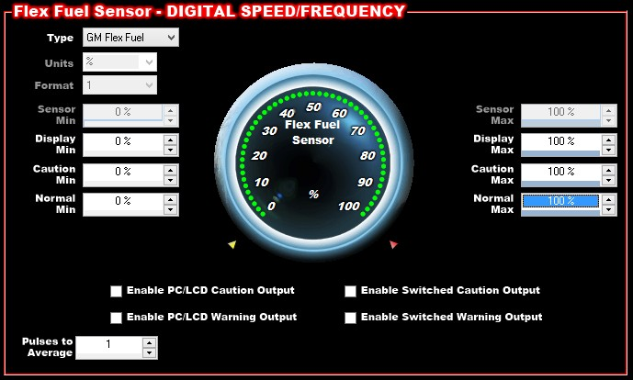

Step 2 – Add the Advanced Tuning ICF. Open a 1D table and enter a name (called “Flex Fuel Mult.” in this example). Select “Fuel Flow Multiplier” for the table type. Select whatever name was given to the flex fuel sensor (“Flex Fuel Sensor” in this example). This table configuration will multiply the final fuel flow value, dependent on this table, based upon what the flex fuel sensor is reporting as the ethanol content of the fuel. This table is set up so that 34% more fuel is added to the final fuel flow, when the sensor is reporting 100% ethanol, which is appropriate for most pump gas and ethanol blended fuels. At this point, these additions would be enough to support basic flex fuel functionality. Steps 3-4 add more tuning options to flex fuel capability.

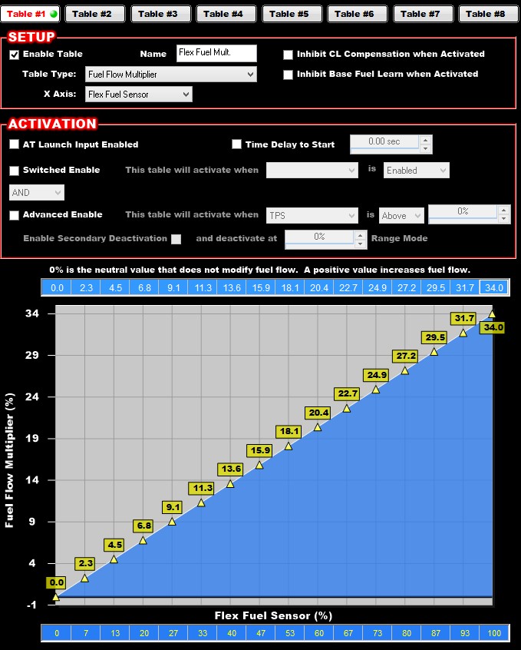

Step 3 – Open another 1D table. Name it “Flex A-F Offset. This table can be used to richen the target Air/Fuel Ratio as load increases, which sometimes can make more power when using E85. You could use a 2D table as well and add another parameter to the table, such as MAP. This would allow one to alter the target A/F based on load and ethanol content.

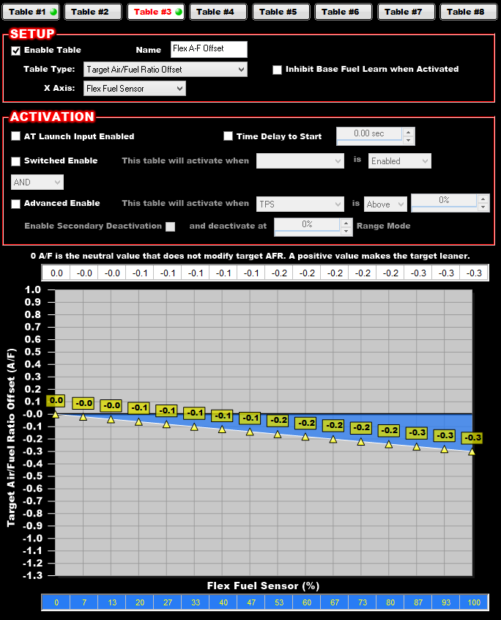

Step 4 – Open another 1D table. This table will alter ignition timing vs ethanol content. The added octane of E85 could allow for a more aggressive timing curve.

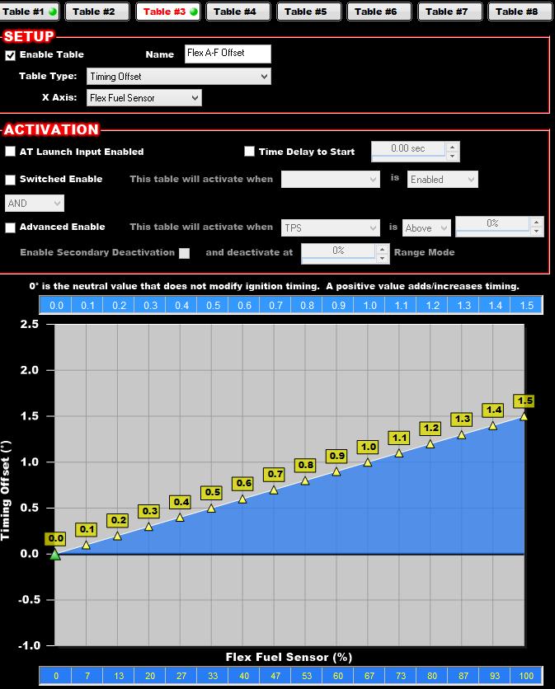

Other tables can be added, such as a ethanol content vs boost curve, what would add more boost with higher ethanol content.

Many Other Possibilities

There are limitless things that can be accomplished with these tables. A few examples.
- Fuel Pressure Compensation Table
- Modification of fuel or timing per gear
- Idle speed or IAC modification for marine or other applications
- Cylinder based Fuel or Timing trims per gear
- Boost control trims based on any parameter
- Nitrous modifications based on any parameter
- Timing advance or retard under many conditions

