Gen III HEMI Harness
(with TPS and Idle Air Control Connections)

P/N 558-115 or 558-116
This wiring harness interfaces a Holley EFI ECU to a Gen III HEMI engine with an aftermarket cable actuated throttle body. It is meant to be used in conjunction with an injector harness, a coil harness, and two ignition modules. Most stock sensors are used with this harness. There are two optional connectors for interfacing with CAN-based Holley modules. There are some loose leads for grounds and power connections.

INSTALLATION:

- The harness was designed to have a main junction point behind the engine. From here a group of 6 connectors goes to the front of the engine (coolant temp, air temperature, camshaft position signal, and oil pressure, throttle position sensor (TPS) and idle air control (IAC)). These should all be plug-and-play. There were some variations in the air temperature sensor for truck applications that used a different connector. If the air temperature sensor does not plug in, you may need to purchase a different style sensor (Chrysler 04606487AB, Standard AX109, Airtex/Wells 5S1024, or equivalent). This kind of sensor is also a push-in style sensor that can be installed in custom ducting.

NOTE: The TPS and IAC connectors are designed for Holley 4 BBL style throttle bodies. If you are using a different throttle body, you may have to change the pins and connectors. The following are the pinouts for the TPS and IAC:

TPS: | A – 5v ref (orange) | B – Sensor Ground (black/white) | C – Signal (Green)
IAC: | A – IAC A Lo (Purple/Blue) | B – IAC B Hi (Purple/Black) | C – IAC B Lo (Purple White)
 | D – IAC A Hi (Purple/Yellow)

- The crankshaft position sensor is on the lower passenger’s side of the block along with the knock sensor for that side. The wiring for these is heat shielded because of the likely proximity to exhaust components. Even so, be sure to restrain the harness so that is cannot contact exhaust surfaces.

- Likewise, on the driver’s side there is a knock sensor. The wiring to it is also heat shielded.

- There is a single black wire with a ring terminal that comes from the main junction point. This must be grounded to one of the heads. There are drilled and tapped holes on the back of the heads (usually M8-1.25mm) that may also be the connection point for a ground strap. Make sure the ring terminal on the black wire is grounded at one of these places.

- The MAP sensor is important to load sensing and is usually located on the top of the manifold toward the rear. Some of the truck applications have manifolds with sensor locations that are considerably more forward. In this case, you may need to extend the wires going to the MAP sensor or use a sensor that connects to a vacuum port on the back of the manifold.

- A connector is included for connecting to a fuel pressure sensor, if desired (Holley 100 PSI Stainless Steel 554- 102). If the fuel pressure measurement is not used, tie the fuel pressure lead such that it will not be damaged since there will be 5V going to that connector whether or not you use the sensor.

- There are two 10 pin connectors to connect to the injector and coil harnesses. Although they look similar, they are keyed differently so they will not plug into the wrong connector. The injector connector is grey while the connector for the coils is black.

- There are two more connectors coming from the main junction that are optional and should be capped when not in use.

The “Power Tap” connector is a convenient place to connect to power and grounds when adding additional sensors or actuators.

  - Power Tap Pin A - Chassis ground
  - Power Tap Pin B - Sensor ground
  - Power Tap Pin C - Sensor 5V
  - Power Tap Pin D - Output from fuel pump relay (battery voltage when engine is running)

The “Inputs/Outputs” connector is used to access the first four inputs and the first four outputs. You will need to purchase Holley P/N 558-400 for the Inputs/Outputs connector (if used).

  - Inputs/Outputs Pin A - Input 1 (ECU pin J1A12) F 5 2 T H G
  - Inputs/Outputs Pin B - Input 2 (ECU pin J1A03) F 5 2 T H G
  - Inputs/Outputs Pin C - Input 3 (ECU pin J1A13) F 5 G
  - Inputs/Outputs Pin D - Input 4 (ECU pin J1A04) F 5 G
  - Inputs/Outputs Pin E - Output 1 (ECU pin J1B12) H P+
  - Inputs/Outputs Pin F - Output 2 (ECU pin J1B11) H P+
  - Inputs/Outputs Pin G - Output 3 (ECU pin J1B10) G P-
  - Inputs/Outputs Pin H - Output 4 (ECU pin J1B03) G P-

- The oxygen sensor uses a shielded jacketed cable that emerges close to the main junction. This will correspond to the “AFR Left” reading in the software, so it would make sense to connect this to the left oxygen sensor. If you are running a Dominator and want to run two oxygen sensors then you need to get the 558-401 J2A adapter harness.

- At the ECU end of the harness, there are four connectors. These connectors are for the ignition modules (not included). PN 554-122 must be purchased separately. 554-122 contains two modules, each of which drives 4 cylinders. One module controls the coils on the bank of odd numbered cylinders, and the other module controls the bank of even numbered cylinders. The modules are interchangeable, but you need to make sure the connectors marked “Odd” go to the same module and the connectors marked “Even” go to the same module.

- There are two CAN connectors that are only used if you have a CAN based accessory.

- There are four loose leads that emerge close to the fuse and relay.

  - Red/White wire - Low current signal to turn on the ECU. Must be energized in start and run position.
  - Red wire - Provides power for relay. Must be energized in start and run position. OK to be powered continuously.
  - Green wire - Relay output for fuel pump up to 15 amps – more than that and the green wire should trigger a separate relay (also powers ignition and injectors)
  - Blue/White wire - Tachometer output (12V square wave 4 pulses/rev)

- ECU connectors - Plug directly into Holley ECU.

SOFTWARE SETUP:

To setup the ECU for a Gen III HEMI you need to select the proper ignition type so the ECU properly interprets the crank and cam signals and fires the coils with the right dwell. You can find this in the system ICF under Ignition Parameters. The Ignition type has three Gen III HEMI specific options. The 558-115 harnesses are for the configurations that use the earlier Chrysler NGC 36-2+2 crank pattern, and the 558-116 harnesses are for the configurations that use the later 60-2 crank pattern. The earliest applications used waste-spark coils, which are easily identifiable by the spark plug wires that cross over the engine.

There are calibrations built into the Holley software for many of the common factory sensors, but they need to be selected as well. These built in calibrations cover most of the Chrysler HEMI applications and can be selected in the Sensors ICF:

- MAP- Chrysler 56041018
- Coolant Temperature Sensor- Chrysler 05149077

- Air Temperature Sensor- Chrysler 56028364
- Oil Pressure Sensor- Chrysler 05149062

The sensor part numbers referenced were used to develop the calibrations. There are many other sensor part numbers that use the same connectors and have the same calibration as the referenced part numbers.

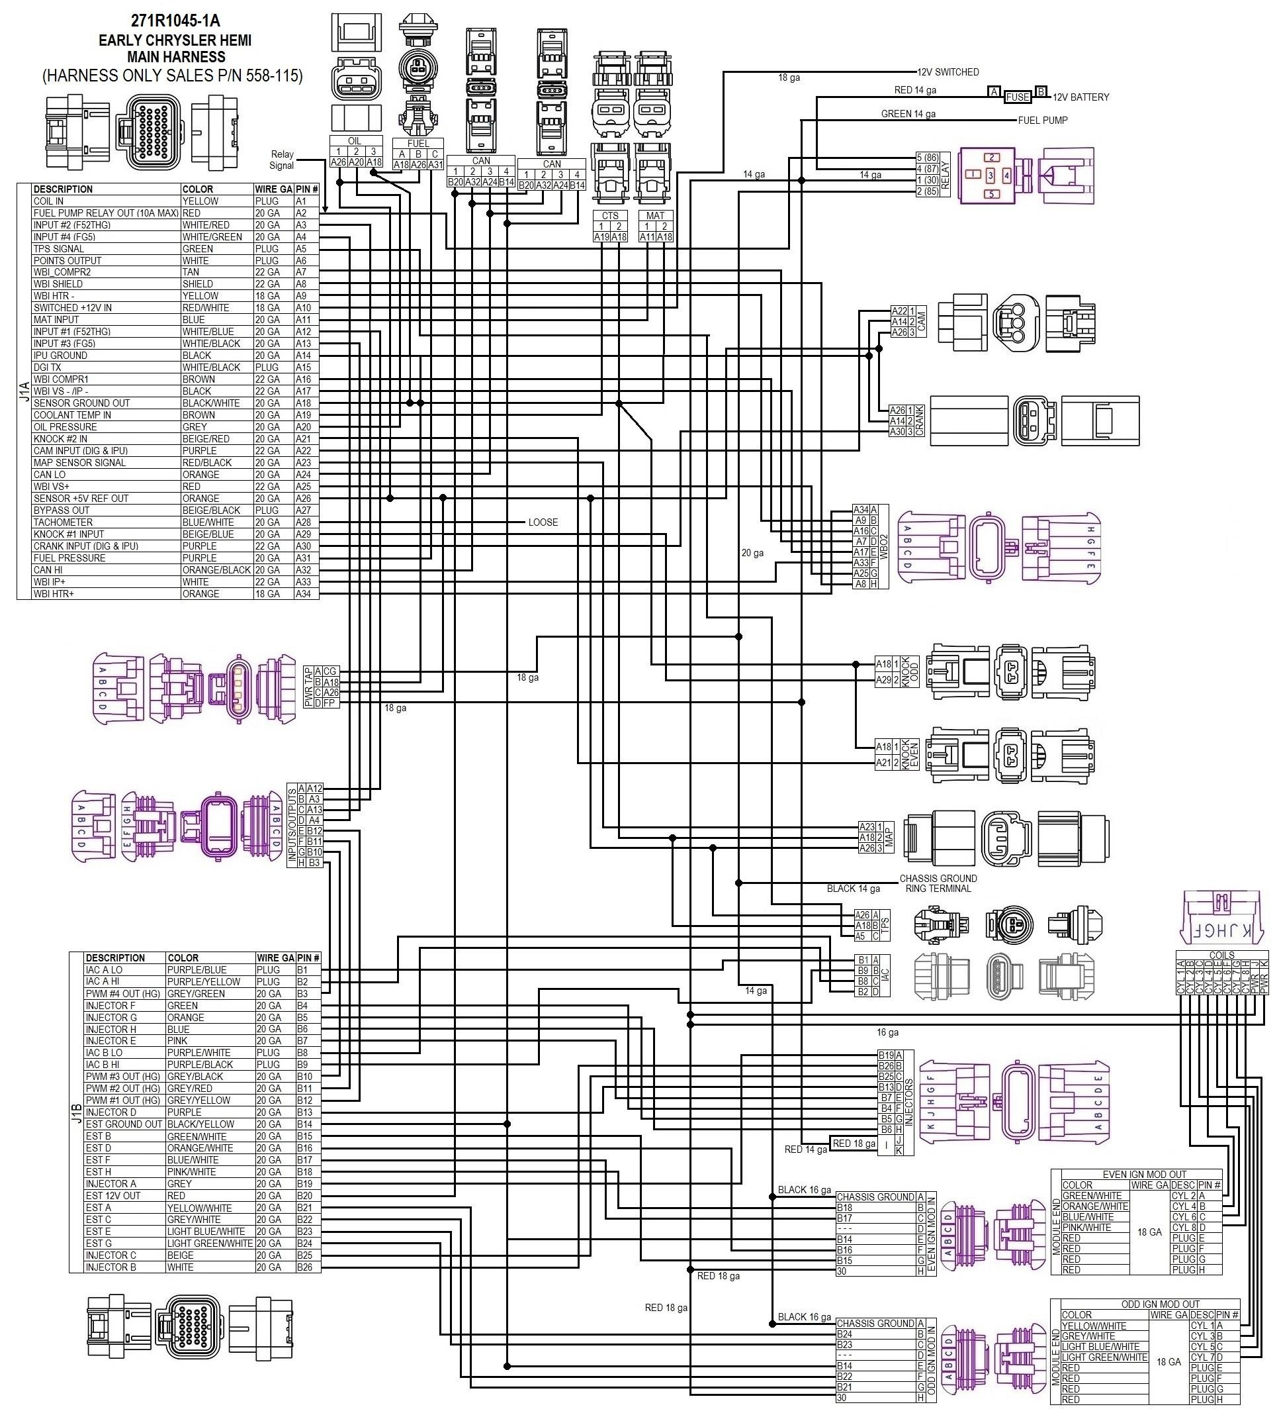

271R1045-1A = 558-115

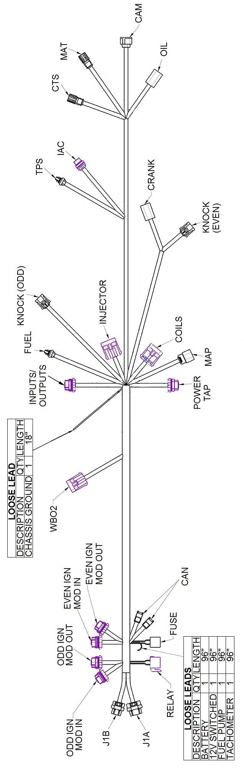

271R1045-2A = 558-115

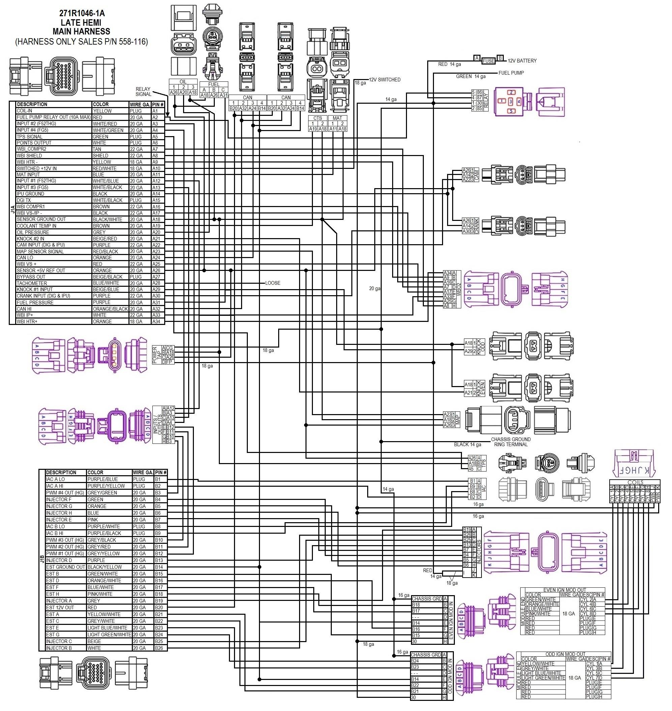
271R1046-1A = 558-116

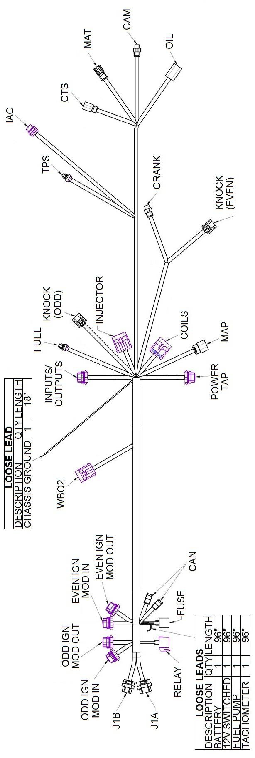

Technical Support: 209-247-6497

