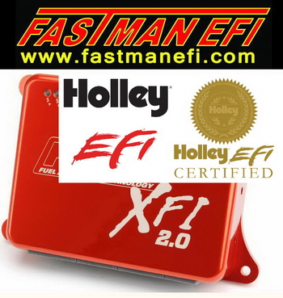
Notes on Knock Sensors
Utilizing the Holley HP or Dominator EFI

* Adjustment of the knock sensor parameters are required such that the ECU can properly distinguish between an actual knock condition, and a non-knock condition. You will have to try and induce a knock condition to make sure that is can be eliminated by the ECU.
* Items such as mechanical (solid) cams can introduce mechanical noise that may inhibit the proper operation of any knock sensor.
Knock sensors output a signal to the ECU. This signal contains a spectrum of many different frequencies. The purpose of a knock sensor is to output a signal in a specific frequency range when knock occurs such that the ECU can recognize the knock condition. The signal when knock occurs should have a much larger amplitude compared to when knock does not exist. This is how the ECU properly determines when knock is and is not occurring. This requires that the proper frequency and sensitivity be input by the user.
There are two basic types of knock sensors: a “Resonant” sensor (which has one wire) and a “Non-Resonant” sensor (which has two wires).
* A 1-wire resonant sensor typically is designed for an intended knock signal frequency. It is affected by the specific engine, chassis, and installation.
* A 2-wire non-resonant sensor has a knock output frequency that is primarily determined by the bore diameter of the engine. A chart is provided below to provide the user with a calculated starting frequency. This is the most common and reliable type of sensor.
Setup Parameters
The following Parameters must be set in the software:
Under System Ignition Parameters: Choose from either “1 wire” (Resonant) or “2 wire” (Non-Resonant) sensors.
Number: Select if the engine has 0, 1, or 2 sensors present.
NOTE: If you are not using any knock sensors, make sure you select 0.
Frequency: This is an adjustable parameter. If this value is not the correct value for the specific sensor and application used, engine knock will NOT be detected. Information for setting this is below.
Sensitivity: This parameter is used to adjust the scaling of the knock sensor signal. If false knock is being detected, it should be lowered. If actual engine knock is NOT being detected, this value can be raised. Start with a value of 50.
The “Knock Level” Parameter: The Knock Level parameter is an ECU output that can be monitored in the Data Monitor and can be data logged. It is THE key parameter when monitoring and tuning knock control. It has a range of 0-100. This value shows the magnitude of the knock sensor output in the frequency range selected. If this value reaches “80” and above, the ECU will read this as a knock event and retard the timing. Values below “80” are not seen as knock.
Initial Frequency Recommendations
Non-Resonant 2-Wire Sensor
The following table is used to input a baseline knock sensor frequency for a NON-RESONANT (2-Wire) sensor. The “Recommended” selection is the line that you want to use to determine a starting point. The “2nd Choice” would be a second selection if for some reason the recommended frequency does not offer the desired outcome. The “3rd Choice” values are typically not used.
To determine the frequency, find the bore diameter in inches for your engine at the bottom of the page (X axis), move up to the “Recommended” line (blue). Move to the left to the Y axis and find the corresponding frequency.
For example, a 5.7L LS1 engine has a bore size of 3.90 inches. This would result in a Theoretical Knock Frequency of 6.0 kHz.
This table offers an excellent starting point for a Non-Resonant sensor. However, tolerances in components may require adjustments.
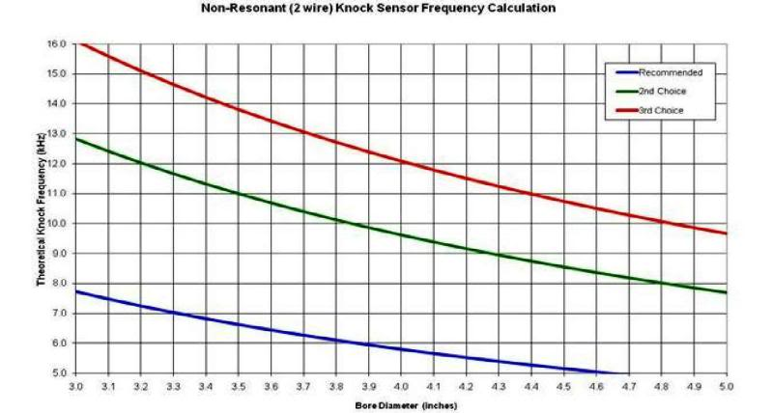
Resonant Sensor
The proper frequency for a Resonant (1-wire) sensor is mostly dependent on the sensor design itself. The engine and chassis also can alter the best frequency selected. It is required to find this information in a service manual or other source if a Resonant sensor is used.
The following is a recommended starting point for two common GM Resonant 1-wire sensors:
AC Delco PN 213-3521, GM PN 12589867 – Commonly used on 1998-2006 GM LSX engines. Frequency – 11.1 kHz
AC Delco PN 213-324, GM PN 10456288 – Used on Late 80s GM engines. Baseline Frequency – 5.2 to 6.5 kHz

“Tuning” The Knock Sensor Settings
NOTE: Inducing knock can harm your engine. If you are testing the sensor response by inducing knock, be VERY careful. If your vehicle is too loud to hear audible knock, you may not be able to perform this test. Be very careful - you do not want to operate an engine under a prolonged knock period. Engine damage can occur.

The following is the recommended process for testing and setting proper knock parameters.
1. Per the recommendations above, set the knock sensor parameters.
2. Make sure the base timing table is calibrated such that you will have no knock at any RPM and load. Set the “Max Timing Retard” in the SPARK/ESC parameters to 0.
3. Drive the vehicle and take a data log. Record at idle, cruise, and WOT. Look at the following parameters on a data log:
· Knock Level
· RPM
· MAP
· TPS
· Ignition Timing
4. Review the log. You specifically want to look at the “Knock Level” parameter. It should never be over 80. If it is, but you didn’t actually hear any ping or knock, you need to lower the “Sensitivity” value until all non-knock conditions result in a Knock Level below 80. When properly adjusted, a WOT knock level value should be around 20-50.
5. Once the Sensitivity is adjusted properly for non-knock levels, enter “Max Timing Retard” (under Spark/ESC) values of whatever you feel the retard would need to be.
6. To check for proper knock retard, the ignition timing can now be advanced to a level that induces knock. When knock occurs, the “Knock Level” should exceed a value of 80 and knock retard should occur. If knock occurs and the knock level is below 80, the Sensitivity is not adjusted properly or the Frequency is not correct.
7. If the Frequency and Knock level are properly set, the knock retard will respond appropriately and remove timing until the knock is eliminated. This is easy to see with a data log.

Terminology
Phantom Knock – This is false triggering of the knock sensor due to an engine's particular vibrational noise at certain RPM/loads. This usually occurs on light acceleration or at mid-range engine operation. Typical causes; valvetrain components (solid lifters, camshaft gear-drives, incorrect rocker arm geometry, etc.), piston-to-cylinder clearances, excessive bearing clearances, mechanical fuel pumps, exhaust systems, solid motor mounts, loose suspension/driveline components contacting exhaust/engine, etc. Knock sensors aren't perfect and modified engines can worsen this condition.
Burst Knock – This can occur during sudden increases in engine load (sudden onset of high torque-WOT). The rapidly rising cylinder pressures may lead to knock under what would otherwise be stable combustion under steady-state engine operation. Many OEMs anticipate this and intentionally program their ECUs to temporarily retard timing a few degrees during these acceleration periods.

